Project Design Phase
Problem – Solution Fit Template

Date | 17 February 2026
Team ID | LTVIP2026TMIDS78778
Project Name | Gemini Historical Artifact Description System
Maximum Marks | 2 Marks

Problem – Solution Fit Template:
The Problem-Solution Fit simply means that you have found a problem with your customer and that the solution you have realized for it actually solves the customer’s problem. It helps entrepreneurs, marketers and corporate innovators identify behavioral patterns and recognize what would work and why
Purpose:
- Solve complex problems in a way that fits the state of your customers.
- Succeed faster and increase your solution adoption by tapping into existing mediums and channels of behavior.
- Sharpen your communication and marketing strategy with the right triggers and messaging.
- Increase touch-points with your company by finding the right problem-behavior fit and building trust by solving frequent annoyances, or urgent or costly problems.
- Understand the existing situation in order to improve it for your target group.

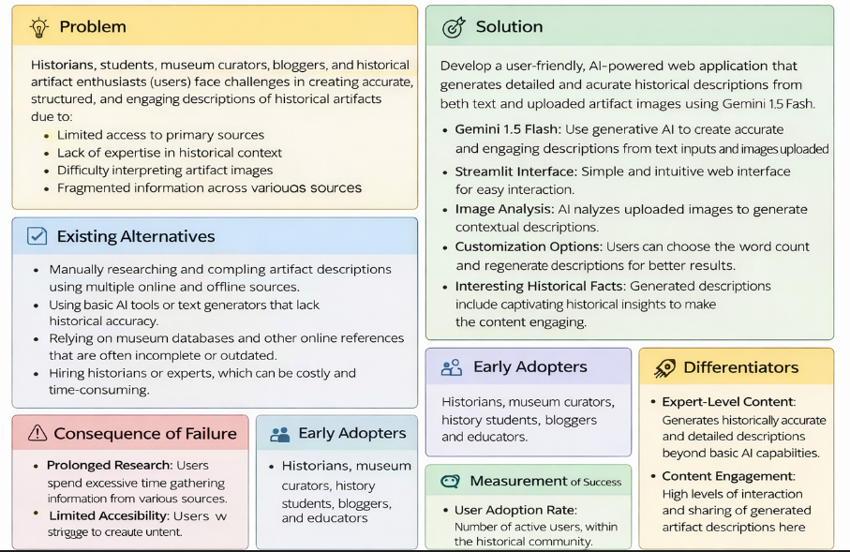

1. Problem
Historians, students, museum curators, bloggers, and history enthusiasts face difficulty in creating accurate, structured, and engaging descriptions of historical artifacts.
The main problems include:
- Limited access to reliable primary historical sources
- Lack of deep historical expertise
- Difficulty in interpreting artifact images
- Time-consuming manual research
- Fragmented information across multiple websites and books
- Inconsistent quality of existing AI-generated content
These challenges make it difficult to quickly generate well-structured and historically accurate artifact descriptions.

2. Existing Alternatives
Currently, users rely on:
- Manual research using books and online sources
- Museum databases and academic journals
- Basic AI text generators (which may lack historical accuracy)
- Hiring experts or historians (costly and time-consuming)
These alternatives are either slow, expensive, or do not guarantee structured and contextually rich outputs.

3. Consequences of the Problem
If the problem is not solved:
- Users spend excessive time researching
- Incomplete or inaccurate artifact descriptions are published
- Reduced engagement in educational content
- Limited accessibility for students and researchers
- Increased dependency on costly expert consultation

4. Proposed Solution
Develop a user-friendly AI-powered web application that:
- Generates detailed historical descriptions using artifact name input
- Analyzes uploaded artifact images
- Provides structured output (Origin, Period, Significance, Facts)
- Allows customization of word count
- Includes interesting historical facts
- Regenerates improved responses
The system uses advanced Generative AI (Gemini model) to produce accurate and context-aware content.

5. Early Adopters
- Historians
- Museum curators
- History students
- Bloggers & content creators
- Educators
- Cultural researchers

6. Unique Value / Differentiators
- Combines text + image-based artifact analysis
- Structured and well-formatted outputs
- Fast content generation (within seconds)
- User-friendly web interface
- Customizable word length
- AI-generated interesting historical insights

7. Measurement of Success
The solution will be considered successful if:
- High user adoption rate
- Reduced time spent on research
- Positive feedback from users
- Increased engagement with generated content
- Frequent usage of image-based artifact analysis

